## Part 2 : Updating Constraints

Log-in to APEX and go to the SQL commands environment

#### Modifying a column

1. Run the DESCRIBE command on the orders table to view its structure.

DESC orders;

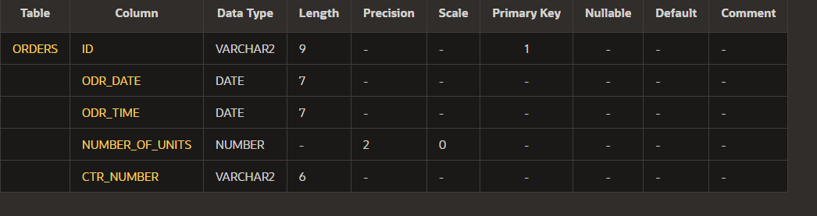

1. **Task**: Add a default constraint that will use todays date to assign a value to the odr_date column of the orders table if no date is provided.

ALTER TABLE orders

MODIFY odr_date DEFAULT SYSDATE;

1. Run the DESCRIBE command again to verify the command was successful.

#### Adding a check constraint

1. Run the DESCRIBE command on the customers table to view its structure.

DESC customers;

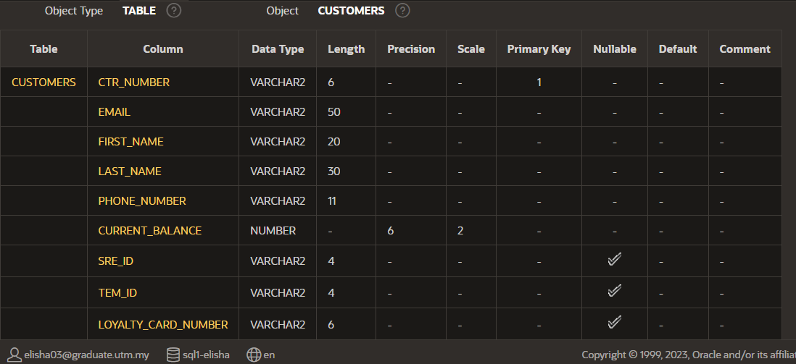

1. **Task**: Add a check constraint that will not allow the customers current balance to go below zero.

ALTER TABLE customers;

ADD CONSTRAINT check_balance CHECK (current_balance >= 0);

1. Run the DESCRIBE command again to verify the command was successful.

1. A check constraint is not shown in the results of a describe command.
   1. Go to the Object Browser
   2. Select the customers table.
   3. Click on the CONSTRAINTS tab.
   4. You will see your constraint here.

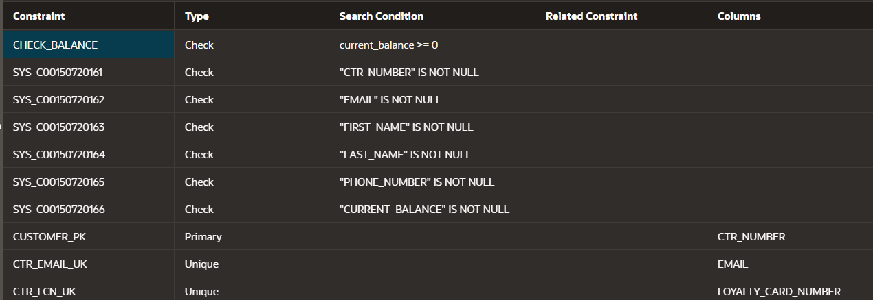

#### Adding a column

The client has decided that they would like a separate column for the customer’s mobile phone number. This is an optional column that will be required to store 11 digits.

1. Run the DESCRIBE command on the customers table to view its structure.

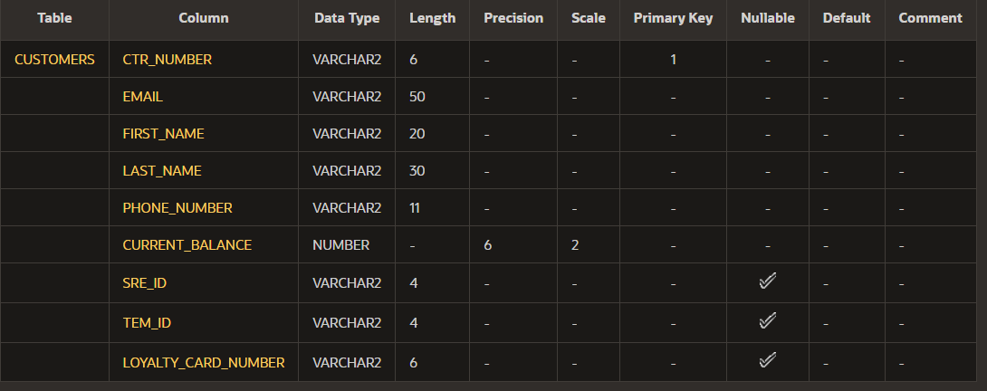

1. **Task**: Add column that will satisfy the clients requirements

ALTER TABLE customers

ADD mobile_phone_number VARCHAR2(11);

1. Run the DESCRIBE command on the customers table to view its structure.

**Dropping a column**

The client has decided that they don’t need the mobile number column as most customers only provide a single contact number and that is already catered for with the existing phone_number column.

1. Run the DESCRIBE command on the customers table to view its structure.

1. **Task**: Drop the column that was created to store the mobile phone number.

ALTER TABLE customers

DROP COLUMN mobile_phone_number;

1. Run the DESCRIBE command on the customers table to view its structure.

